ENARSI Skills Assessment - Troubleshooting

# Topology

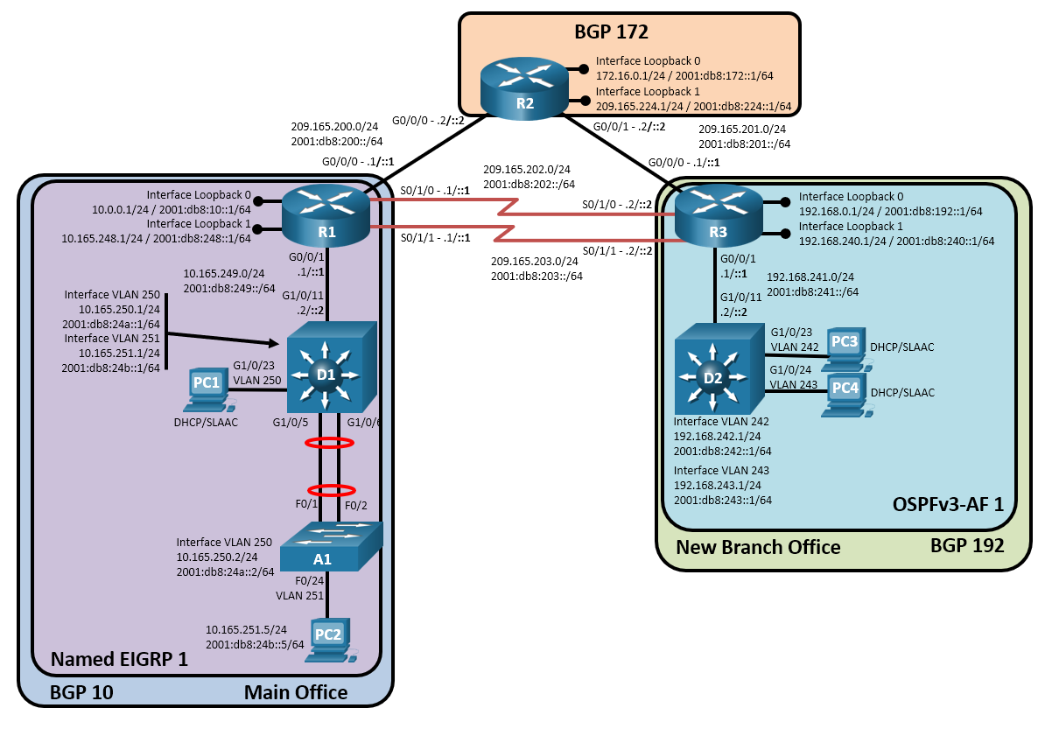

# Addressing Table

| Device | Interface | IPv4 Address/Mask | IPv6 Address/Prefix Length | Link-Local Address |
| --- | --- | --- | --- | --- |
| R1 | G0/0/0 | 209.165.200.1/24 | 2001:db8:200::1/64 | fe80::1:1 |
| R1 | G0/0/1 | 10.165.249.1/24 | 2001:db8:249::1/64 | fe80::1:2 |
| R1 | Loopback 0 | 10.0.0.1/24 | 2001:db8:10::1/64 | fe80::1:3 |
| R1 | Loopback 1 | 10.165.248.1/24 | 2001:db8:248::1/64 | fe80::1:4 |
| R2 | G0/0/0 | 209.165.200.2/24 | 2001:db8:200::2/64 | fe80::2:1 |
| R2 | G0/0/1 | 209.165.201.2/24 | 2001:db8:201::2/64 | fe80::2:2 |
| R2 | Loopback 0 | 172.16.0.1/24 | 2001:db8:172::1/64 | fe80::2:3 |
| R2 | Loopback 1 | 209.165.224.1/24 | 2001:db8:224::1/64 | fe80::2:4 |
| R3 | G0/0/0 | 209.165.201.1/24 | 2001:db8:201::1/64 | fe80::3:1 |
| R3 | G0/0/1 | 192.168.241.1/24 | 2001:db8:241::1/64 | fe80::3:2 |
| R3 | Loopback 0 | 192.168.0.1/24 | 2001:db8:192::1/64 | fe80::3:3 |
| R3 | Loopback 1 | 192.168.240.1/24 | 2001:db8:240::1/64 | fe80::3:4 |
| D1 | G1/0/11 | 10.165.249.2/25 | 2001:db8:249::2/64 | fe80::d1:1 |
| D1 | VLAN 250 | 10.165.250.1/24 | 2001:db8:24a::1/64 | fe80::d1:2 |
| D1 | VLAN 251 | 10.165.251.1/24 | 2001:db8:24b::1/64 | fe80::d1:3 |
| D2 | G1/0/11 | 192.168.241.2/24 | 2001:db8:241::2/64 | fe80::d2:1 |
| D2 | VLAN 242 | 192.168.242.1/24 | 2001:db8:242::1/64 | fe80::d2:2 |
| D2 | VLAN 243 | 192.168.243.1/24 | 2001:db8:243::1/64 | fe80::d2:3 |
| A1 | VLAN 250 | 10.165.250.2/24 | 2001:db8:24a::2/64 | fe80::a1:1 |
| PC1 | NIC | DHCP | SLAAC | EUI-64/CGA |
| PC2 | NIC | 10.165.251.5/24 | 2001:db8:24b::5/64 | EUI-64/CGA |
| PC3 | NIC | DHCP | SLAAC | EUI-64/CGA |
| PC4 | NIC | DHCP | SLAAC | EUI-64/CGA |

# Objectives

Troubleshoot network issues related to the configuration and operation of routing protocols.

# Background / Scenario

This is the same topology that you built in Part 1 of the ENARSI SA. In this topology, R1 and D1 are EIGRP neighbors and R3 and D2 are OSPF neighbors. R1, R2, and R3 are all speaking BGP for their respective ASNs. Switch A1 is supporting host access for a AAA server. You will be loading configurations with intentional errors onto the network. Your tasks are to FIND the error(s), document your findings and the command(s) or method(s) used to fix them, FIX the issue(s) presented here and then test the network to ensure both of the following conditions are met:

* + - * 1. the complaint received in the ticket is resolved
        2. full reachability is restored

**Note**: The routers used with CCNP hands-on labs are Cisco 4221 with Cisco IOS XE Release 16.9.4 (universalk9 image). The switches used in the labs are Cisco Catalyst 3650 with Cisco IOS XE Release 16.9.4 (universalk9 image) and Cisco Catalyst 2960 with Cisco IOS Release 15.2(2) (lanbasek9 image). Other routers, switches, and Cisco IOS versions can be used. Depending on the model and Cisco IOS version, the commands available and the output produced might vary from what is shown in the labs. Refer to the Router Interface Summary Table at the end of the lab for the correct interface identifiers.

**Note**: Make sure that the devices have been erased and have no startup configurations. If you are unsure, contact your instructor.

**Note**: The default Switch Database Manager (SDM) template on a Catalyst 2960 does not support IPv6. You must change the default SDM template to the dual-ipv4-and-ipv6 default template using the **sdm prefer dual-ipv4-and-ipv6 default** global configuration command. Changing the template will require a reboot.

# Required Resources

* 3 Routers (Cisco 4221 with Cisco IOS XE Release 16.9.4 universal image or comparable)
* 2 Switches (Cisco 3650 with Cisco IOS XE Release 16.9.4 universal image or comparable)
* 1 Switch (Cisco 2960 with Cisco IOS Release 15.2(2) lanbasek9 image or comparable)
* 3 PCs (Choice of operating system with terminal emulation program installed)
* 1 PC (Choice of operating system with a server running configured RADIUS (Optional))
* Console cables to configure the Cisco IOS devices via the console ports
* Ethernet and serial cables as shown in the topology

# Scenario

You had the network working to specifications and took a week off. While you were gone, a junior administrator and a security engineer were tasked to improve the network. The opposite occurred. Now you are tasked with fixing the network.

The instructions the junior administrator and security engineer were given were as follows:

1. Reduce the number of TCP sessions between R1 and R3.
2. Apply IPv4 and IPv6 filters to the outward-facing interfaces on R1 and R3 to ensure that inbound traffic sourced from their local networks is dropped.
3. Reduce the size of the EIGRP routing table on R1.
4. Reduce the number of route entries R1 is sending to R2.
5. Incorporate AAA using the AAA server at 209.165.251.5 to secure remote access to all devices in the AS 10 and AS 192 networks.

They did not document things as they were supposed to, so all you have been told is things are not working as they should be. You need to fix all of this as soon as possible!

Use the commands listed below to load the configuration files for this skills assessment:

|  |  |
| --- | --- |
| Device | Command |
| R1 | **copy flash:/enarsi/sa-tshoot-r1-config.txt run** |
| R2 | **copy flash:/enarsi/sa-tshoot-r2-config.txt run** |
| R3 | **copy flash:/enarsi/sa-tshoot-r3-config.txt run** |
| D1 | **copy flash:/enarsi/sa-tshoot-d1-config.txt run** |
| D2 | **copy flash:/enarsi/sa-tshoot-d2-config.txt run** |
| A1 | **copy flash:/enarsi/sa-tshoot-a1-config.txt run** |

* Console Passwords on all devices are **cisco12345**. If a username is required, use **admin**.
* Remote access should be available using the username **raduser** and password **upass123**.
* PC2 must be configured with static addresses as shown in the topology diagram/addressing table. PC1, PC3, and PC4 will dynamically acquire IPv4 and IPv6 addresses.
* When you have fixed the ticket, change the MOTD on EACH DEVICE using the following command:

**banner motd # This is $(hostname) FIXED Skills Assessment #**

* Save the configuration by issuing the **wri** command (on each device).
* Inform your instructor that you are finished.
* After the instructor approves your solution, issue the **reset.now** privileged EXEC command. This script will clear your configurations and reload the devices.

# Router Interface Summary Table

| Router Model | Ethernet Interface #1 | Ethernet Interface #2 | Serial Interface #1 | Serial Interface #2 |
| --- | --- | --- | --- | --- |
| 1800 | Fast Ethernet 0/0 (F0/0) | Fast Ethernet 0/1 (F0/1) | Serial 0/0/0 (S0/0/0) | Serial 0/0/1 (S0/0/1) |
| 1900 | Gigabit Ethernet 0/0 (G0/0) | Gigabit Ethernet 0/1 (G0/1) | Serial 0/0/0 (S0/0/0) | Serial 0/0/1 (S0/0/1) |
| 2801 | Fast Ethernet 0/0 (F0/0) | Fast Ethernet 0/1 (F0/1) | Serial 0/1/0 (S0/1/0) | Serial 0/1/1 (S0/1/1) |
| 2811 | Fast Ethernet 0/0 (F0/0) | Fast Ethernet 0/1 (F0/1) | Serial 0/0/0 (S0/0/0) | Serial 0/0/1 (S0/0/1) |
| 2900 | Gigabit Ethernet 0/0 (G0/0) | Gigabit Ethernet 0/1 (G0/1) | Serial 0/0/0 (S0/0/0) | Serial 0/0/1 (S0/0/1) |
| 4221 | Gigabit Ethernet 0/0/0 (G0/0/0) | Gigabit Ethernet 0/0/1 (G0/0/1) | Serial 0/1/0 (S0/1/0) | Serial 0/1/1 (S0/1/1) |
| 4300 | Gigabit Ethernet 0/0/0 (G0/0/0) | Gigabit Ethernet 0/0/1 (G0/0/1) | Serial 0/1/0 (S0/1/0) | Serial 0/1/1 (S0/1/1) |

**Note**: To find out how the router is configured, look at the interfaces to identify the type of router and how many interfaces the router has. There is no way to effectively list all the combinations of configurations for each router class. This table includes identifiers for the possible combinations of Ethernet and Serial interfaces in the device. The table does not include any other type of interface, even though a specific router may contain one. An example of this might be an ISDN BRI interface. The string in parenthesis is the legal abbreviation that can be used in Cisco IOS commands to represent the interface.

End of document